Title of paper
Author
Affiliation or Independent artist
author@email.address
Submitted: date
Abstract: Please insert your abstract text here in Times New Roman, 10pt font.

[Name of Creative Work] Accessible here: Put the Zenodo link to your work here and the DOI number from Zenodo

Headings
Here is an example of a paragraph text. Please use Times New Roman, 12pt font for your paragraph. Please indent the first line of each paragraph by 1.27cm (Right-click > paragraph > Indentation > Special > First line > 1.27cm).
Please reference using APA 7. In-text citations should look like this (Author, date) or Author (date). Direct quotes should “look like this with author, year and page number” (Author, year, p. )
Figure 1. This is an example figure title.
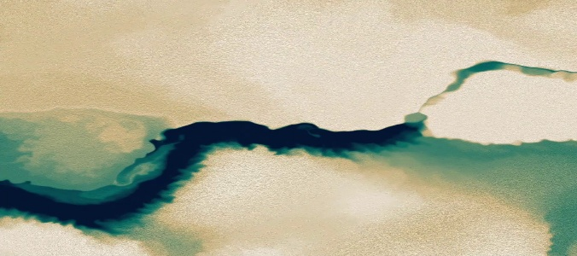
Note: This is an example text describing the figure.

